Dear Parents,

We will be making our school a phone-free space to improve teaching and learning using a system called Yondr. Yondr has been implemented in over 2,000 schools across 16 countries to facilitate an engaged learning environment.

We believe that phones have great utility. We have also found that learning and social behavior improve drastically when students are fully engaged with their teachers and classmates.

The Yondr Program utilizes a simple, secure pouch that stores a phone. Every student will secure their phone in a personally assigned Yondr pouch when they arrive at school. Students will maintain possession of their phones and will not use them until their pouches are opened at the end of the school day. Students are required to bring their Yondr pouch to and from school each day and are responsible for their pouch at all times.

Yondr recently surveyed over 900 school partners to measure the effects of creating phone-free educational environments. These schools achieved notable progress in multiple areas:

- 65% of schools saw an improvement in academic performance
- 74% of schools saw an improvement in student behavior
- 83% of schools saw an improvement in student engagement in the classroom

If you have any questions, please do not hesitate to contact the school directly at (413)750-2333, or attend one of our upcoming meetings about the adoption of Yondr August 24th 2023 from 4-6 P.M.

If there is an emergency and you would like to get in contact with your child, please reach out to at (413)750-2333.

In an effort to best serve your child, we appreciate your full support in adoption of the Yondr Program at our school.

Thank you,
Impact Prep Middle School

How Yondr Works
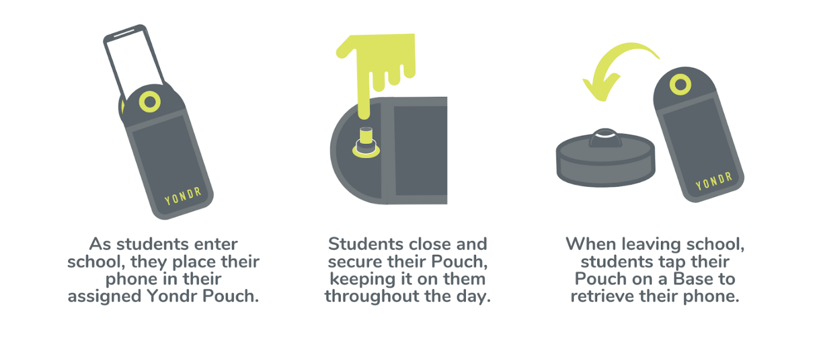

Frequently Asked Questions
What if I want to reach my child during the school day?
We want our students to be engaged in their learning. If you need to contact your child during the school day, contact the main office at (413)750-2333.

What if there is a school emergency?
In case of a school emergency, we direct our students to safety first, following our school emergency preparedness protocol.

Will my student’s phone be safe?
Students are in possession of their phone - in their Yondr pouch - for the entire school day. We will advise students to store the pouch in their backpacks where it is completely safe.

What if the Yondr pouch gets damaged or a student is caught on their phone?
The Yondr pouch is property of Impact Prep Middle School. If a student damages their Pouch or is caught on their phone, Administration will collect the phone/Pouch and call home:

● The Parent will come to the school and pick up their child’s phone
● AND/OR Consequences may include: Community Service / In-School
Suspension / Detention

Note: Damage consists of any signs that the physical integrity of the pouch has been compromised, whether intentional or unintentional, as determined by the school or Yondr staff.

